Multiple-choice section

|  |  |  |  |  |  |  |  |  |
| --- | --- | --- | --- | --- | --- | --- | --- | --- |
| Question | 1 | 2 | 3 | 4 | 5 | 6 | 7 | 8 |
| Answer | A | C | D | A | C | D | B | B |

Question 1 [5.1]

A

5*p* − 3 = 7

5*p* − 3 + 3 = 7 + 3 (add 3 to 7)

5*p* = 10

 =  (divide the answer by 5)

*p* = 2

Question 2 [5.2]

C

If *x* is the number of boys, then the number of girls is *x* + 5.

The number of boys and girls in the class is 23.

*x* + *x* + 5 = 23

2*x* + 5 = 23

Question 3 [5.3]

D



Question 4 [5.4]

A

Substitute *a* = 1 into the equation to find the value of *b*.

*b* = 5*a* − 6

= 5 × 1 − 6

= 5 − 6

= -1

Question 5 [5.5]

C

gradient = 

Question 6 [5.6]

D

The product of the gradients of perpendicular lines is -1: *m*1 × *m*2 = -1

The gradient of *y* = 3*x* – 7 is 3.

The general equation of a straight line is *y* = *mx* + *c*, so substitute *m1* = 3:

3 × *m*2 = -1

*m*2 = 

Question 7 [5.7]

B

Substitute values for the *x*-coordinates into the equation of the line and see whether the   
*y*-coordinate is obtained.

When *x* = 2:

*y* = 3 − 4 × 2

*y* = 3 − 8

*y* = -5

The point (2, -5) lies on the line.

Question 8 [5.8]

B

a vertical line passing through *x* = 3

a horizontal line passing through *y* = -2

Multiple-choice total marks: 8

Short answer section

Question 9 3 marks [5.1]

2(2*x* − 1) = 10

4*x* − 2 = 10

4*x* − 2 + 2 = 10 + 2

4*x* = 12

 =  = 3

Question 10 4 marks [5.2]

Let *D* be David’s age. Greg is twice David’s age, so let 2*D* be Greg’s age.

If the sum of their ages is 36, then:

*D* + 2*D* = 36

3*D* = 36

= 

*D* = 12

David is 12 years old. Since Greg = 2*D*, then Greg is 2  12 = 24 years old.

Question 11 3 marks [5.3]

Let (*x*1, *y*1) = (2, 5) and (*x*2, *y*2) = (6, 11)

Here, *x*1 = 2, *x*2 = 6, *y*1 = 5, *y*2 = 11

Write the midpoint formula, substitute in the relevant values, and evaluate.



*M* = (4, 8)

Question 12 4 marks [5.4]

(a)

|  |  |  |  |  |
| --- | --- | --- | --- | --- |
| P | 0 | 3 | 6 | 9 |
| T | -4 | 5 | 14 | 23 |

**(b)**

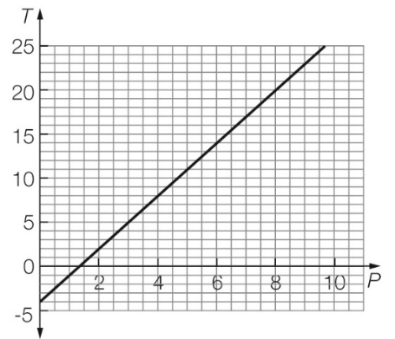

Question 13 3 marks [5.5]

*m* = 

= 

The points are (-3, 5) and (1, 1).

Let *x*1 = -3, *x*2 = 1, *y*1 = 5, *y*2 = 1



*m* = -1

Question 14 4 marks [5.6]

(a) *m* = 3, *b* = -2

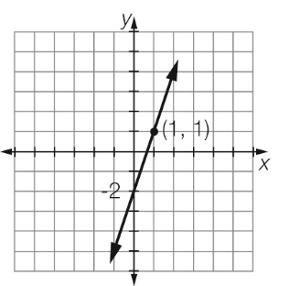

Question 15 4 marks [5.7]

*x* + 2*y* = 4

*x*-intercept:

*y* = 0

*x* + 2 × 0 = 4

*x* = 4

*x-*intercept= (4, 0)

*y-*intercept:

*x* = 0

0 + 2*y* = 4

2*y* = 4

*y* = 2

*y*-intercept = (0, 2)

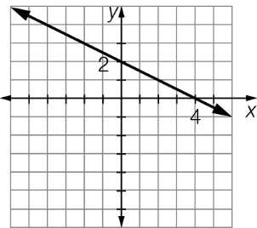

Question 16 2 marks [5.8]

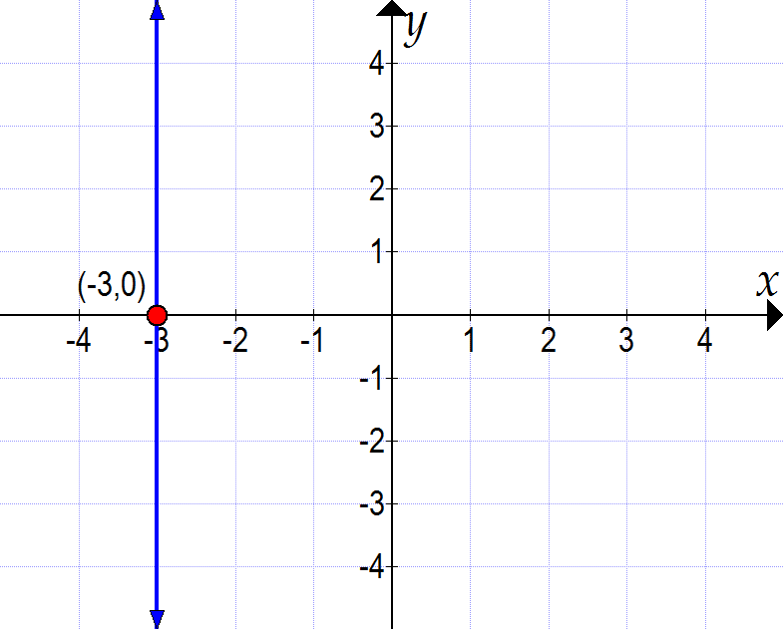

Short answer total marks: 27

Extended answer section

Question 17 2 + 2 + 3 +3 + 2 marks [5.2, 5.4, 5.5]

(a)

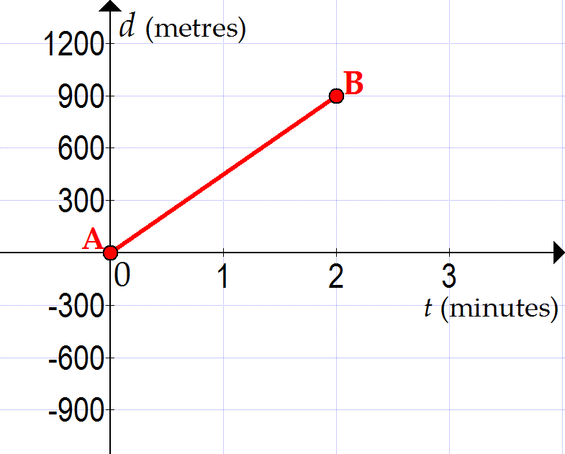

(b) *m* = 

= 

The points are (0, 0) and (2, 900).

Let *x*1 = 0, *x*2 = 2, *y*1 = 0, *y*2 = 900



*m* = 450

Since *m* = , the units are *m* = , or metres per minute.

(c) Using *y* = *mx* + *c*, or *d* = *mt* + *c*:

*c* = 0, *m* = 450

Substitute into *d* = *mt* + *c*:

*d* = 450*t* + 0

*d* = 450*t*

(d) *d* = 450*t*

Substitute *d* = 9000 m (9 km).

9000 = 450*t*

 = 

20 = *t*, or *t* = 20 minutes

(e) Substitute 0, 1, 2, 3, 4, 5 into *d* = 450*t* to complete the table.

|  |  |  |  |  |  |  |
| --- | --- | --- | --- | --- | --- | --- |
| t | 0 | 1 | 2 | 3 | 4 | 5 |
| d | 0 | 450 | 900 | 1350 | 1800 | 2250 |

Question 18 2 + 3 + 3 + 3 marks [5.3, 5.4, 5.6]

(a)

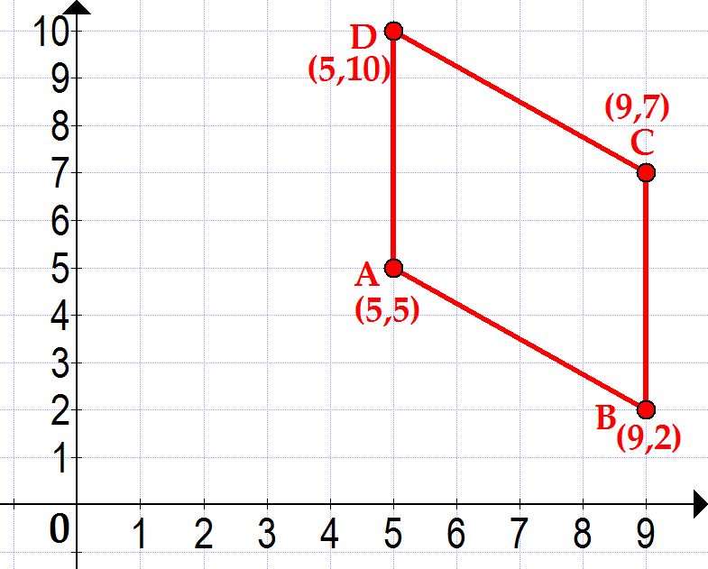

(b) Let *A*(*x*1, *y*1) = (5, 5) and *B*(*x*2, *y*2) = (9, 2)

Here, *x*1 = 5, *x*2 = 9, *y*1 = 5, *y*2 = 2

Write the distance formula, substitute in the relevant values, and evaluate. Include units in your answer.



*AB* = 5 units

(c) Side *BC* is parallel to the *y*-axis, i.e. it is a vertical line. Its equation is *x* = 9.

(d)

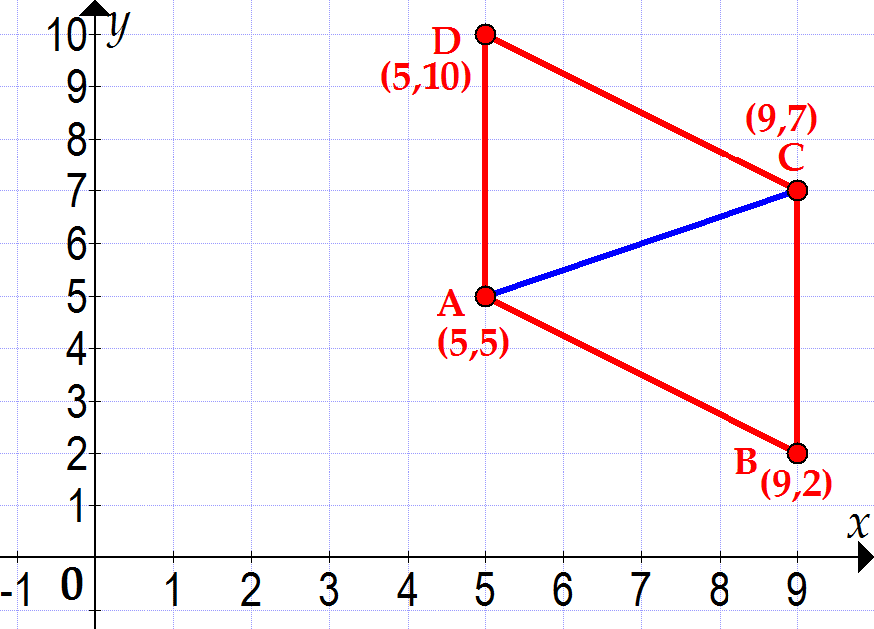

Diagonal *AC*:

Let (*x*1, *y*1) = (5, 5) and (*x*2, *y*2) = (9, 7)

Here, *x*1 = 5, *x*2 = 9, *y*1 = 5, *y*2 = 7

Write the midpoint formula, substitute in the relevant values, and evaluate.



*MAC* = (7, 6)

Extended answer total marks: 23

TOTAL test marks: 58